MINI PROJECT REPORT ON
MOVIE RECOMMENDATION SYSTEM
SUBMITTED BY
Muskan Gupta Archit Bansal
161500335 161500119
Aditya Singh Rathore Arpit Dwivedi
161500037 161500123
TO
Miss Aikta Arya - Assistant Professor
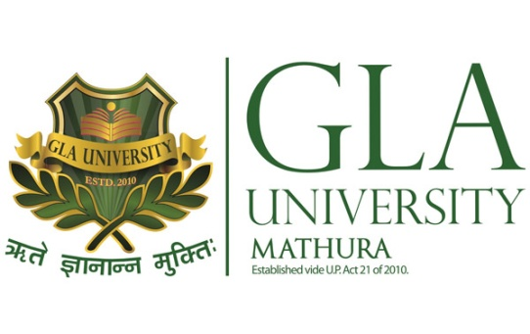
Department of Computer Engineering & Applications
Institute of Engineering and Technology
GLA University
Mathura-281406, INDIA
August, 2018

TABLE OF CONTENTS

- Declaration……………………………………………………………i
- Certificate…………………………………………………………….ii
- Acknowledgement…..……………………………………………….iii
- Abstract………………………………………………………………iv

- Introduction…………………………………………………………1-3
  - Overview and Motivation
  - Method used
  - Summary of more applications

- Project Design……………………………………………………….5-7
  - DFD Data Flow Diagram
  - Use Case Diagram
  - Database Description

- Implementation and User Interface………………………………8-19
  - User Interface
  - Implementation

- References/Bibliography……………………………………………20

DECLARATION
We hereby declare that the work which is being presented in the Mini Project Report “TITLE: Movie Recommendation System”, in partial fulfillment of the requirement for Mini Project LAB, is an authentic record of our work carried under the supervision of Miss Aikta Arya (Assistant Professor), GLA University, Mathura.

Sign:

Muskan Gupta(161500335)
Aditya Singh Rathore(161500037)
Archit Bansal(161500119)
Arpit Dwivedi(161500123)

CERTIFICATE

This is to certify that the project entitled “Movie Recommendation System” carried out in Mini Project – Lab is a bonafide work done by Muskan Gupta (161500335), Aditya Singh Rathore (161500119), Arpit Dwivedi (161500123) and Archit Bansal (161500119) and is submitted in partial fulfillment of the requirements for the award of the degree Bachelor of Technology (Computer Science & Engineering).

Signature of Supervisor:

Miss Aikta Arya
(Assistant Professor)

ACKNOWLEDGEMENT
It gives us a great sense of pleasure to present the report of the B. Tech Mini Project undertaken during B.Tech. Third Year. This project in itself is an acknowledgement to the inspiration, drive and technical assistance contributed to it by many individuals. This project would never have seen the light of the day without the help and guidance that we have received.

Our heartiest thanks to Dr. (Prof). Anand Singh Jalal, Head of Dept., Department of CEA for providing us with an encouraging platform to develop this project, which thus helped us in shaping our abilities towards a constructive goal.

We owe special debt of gratitude to Miss Aikta Arya, Assistant Professor Department of CEA, for her constant support and guidance throughout the course of our work. Her sincerity, thoroughness and perseverance have been a constant source of inspiration for us. She has showered us with all her extensively experienced ideas and insightful comments at virtually all stages of the project & has also taught us about the latest industry-oriented technologies.

We also do not like to miss the opportunity to acknowledge the contribution of all faculty members of the department for their kind guidance and cooperation during the development of our project. Last but not the least, we acknowledge our friends for their contribution in the completion of the project.

Muskan Gupta (161500335)
Aditya Singh Rathore (161500037)
Arpit Dwivedi (161500123)
Archit Bansal (161500119)

ABSTRACT
Recommendation systems have become ubiquitous in our lives. Yet, currently, they are far from optimal. In this project, we attempt to understand the different kinds of recommendation systems and compare their performance on the MovieLens dataset. We attempt to build a scalable model to perform this analysis.
This project proposes the use of soft computing techniques to develop recommendation systems. It addresses the limitations of current algorithms used to implement recommendation systems, evaluation of experimental results, and conclusion.

